UNIT 4.2

THE COMPUTER SYSTEMS AND SOFTWARE
TUTOR NAME: MS. FATHIMA

SUBMITTED BY FATIMA EJAZ BARRI

TABLE OF CONTENTS
TASK 1.1 Describe components of different computer systems
TASK 1.3 Assess the function of components within a chosen computer system
TASK 2.2 Critically assess the use of different software applications to meet specific purposes
TASK 2.3 Assess the use of web applications to enhance user experience

LO1-
  - Describe the components of different computer system
Computer system: The computer system has one or more data inputs. Then this data will be processed in some way. The result of the processing is sent to an output or it can be processed until there is some event that cause it to be generated.

CPU
Memory unit

Control unit
ALU
Output unit
Secondary storage device
Input unit
Softcopy devices example: monitor
Hard copy devices example: printer, plotter.
Example: keyboard, mouse, light, pen, joystick etc.

Example: magnetic tape, magnetic disks, CDS, etc.
Peripheral devices
Central processing unit: the central processing unit (CPU) is called the computer control unit and the ALU together. The CPU functions as a human brain.
Input unit: data and instructions must be implemented in the computer system before any operation can be done on the on the data presented. The input device connecting the external environment to the computer system does this function. Input unit types that depend on the system used enter data and instructions. For example, data is entered from a keyboard in a type manner and this varies from the way data is entered through a mouse, which is another form of system input. However all input device must provide data to a computer that is transformed into the binary codes that the primary memory computers are programmed to accept regardless of how they receive their inputs. Devices called input interfaces carry out the transformation. Input interfaces are configured with the unique physical or electrical characteristics of input devices to match computer system requirements.
In short, an input device carries out the following functions.
- It accepts (or reads) the list of instructions and data from outside the world.
- It converts these instructions and data into the machines acceptable format.
- It contains the instructions and data that are transferred to the computer system for further processing.
Output unit: working devices are the input devices reverse side. It provided information and computing results to the outside world. Because computers operate in binary code, it connects the computer to the external environment the results are also in the binary. Therefore, before suppling the results to the outside world, it must be converted into an acceptable (readable) human. This task is performed by devices called output interfaces.
In short, the following functions are carried by an output device.
- It accepts the results produced by the machine that are coded and that we cannot be easily understand.
- It transforms these coded outcomes in to an accepted (readable) human form.
- It provided the converted results to the outside world.
Storage unit: The storage unit carries data and instructions entered through the input unit before being processed. Before being sent to the output devices, it preserves the intermediate and final results.
Secondary Storage: for a long time, secondary storage is used to store data. It stores documents databases and so on from various programs. The programs that you run on your computer are first transferred to the primary memory before it runs. When the result is retrieved, these are stored in the secondary memory. The hard disk drive is an example for storage.
Arithmetic Logical Unit: the arithmetic logic unit (ALU) performs all calculations. Comparisons are also made and decisions are taken. The ALU is able to perform arithmetic and logical basic operations.
Control Unit: all other computer units are controlled. The control unit instructs the input unit after the user has obtained it, where the data should be proceed. It controls the flow of data and instructions from the storage unit to ALU. It also controls the flow to the ALU test storage unit. Generally, the control unit is generally referred to as the central nervous system that regulate and synchronize their operation.
Memory Unit: computer memory is any physical device that can temporarily store information on a permanent basic, either a RAM (random access memory), or ROM (read-only memory). Memory units use built-in circuits and are used by hardware applications and operating systems.

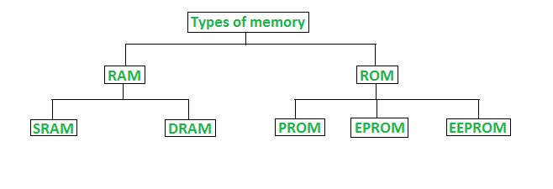
Random Access Memory (RAM): RAM is called random access memory, which in a computer that temporarily stores data is essential hardware. It also acts as the operating memory. it computers allows a computer to operate with more knowledge at the same time without harming system performance.
Types of RAM
two main types of RAM
- Dynamic random access memory (DRAM)
- Static random access memory (SRAM)
Dynamic Random Access Memory
- Constructed of tiny electric leak-leak capacitors.
- Requires a charge to maintain its data every milliseconds.
- Low-cost.
- Less than SRAM
- Multiple bits can be stored per chip.
- Less fuel is used.
Static Random Access Memory
- Their contents are started as long as there is power.
- It’s costly.
- Faster than DRAM.
- Cannot store of a lot bits per chip.
- Uses power.
- Gives more heat.
- Used for a cache
Read-Only Memory (ROM): is a non-volatile memory type of computers and other electronic devices.
Types of ROM
There are three main ROM types.
- PROM
- EPROM
- EEPROM
Programmable Read Only Memory (PROM)
PROM is ready only for the memory chip that a user can reach only once. The difference is that during the production process, ROM is programmed; PROM is produced as a bank memory. The user buys a PROM; after making it, the user needs a special device called a PROM programmed by “Blowing” the fuses, which is an irreversible process.
Erasable programmable read only memory (EPROM)
EPROM programming is basically the same as a PROM. However it is possible to delete and reprogram EROMs repeatedly. To delete an EPROM, simple expose the device to a powerful ultraviolet light source. (A window in the top of the device allows the light to reach the silicon.) this allows you reset the whole chip to its initial un-programmed-state. Although more costly than PROMs, their reprogramming ability makes EROMS an essential part of the software development process and not the start-up instructions testing process.
Electrically erasable programmable read only memory (EEPROM)
EEPROM is a special PROM type that can be removed by exposure to electricity. Like other ROMs, although if the power is switched off it retains its memory.one byte at a time, data is written or erased. EEPROMS can be extinguished and programmed. Internally, they are identical to EPROMS but the erase process is performed electrically, not with the penetration of ultraviolet light. Any byte within an EEPROM that may have been deleted and reused. Once the new data has been written, it will remain in the device for good or at least until it is electrically erased. For this increased flexibility, the primary trade-off is higher cost, although processing cycles are also significantly longer than written to a RAM. Therefore, you would not want to use an EEPROM for your main system memory.
  - Analyse networking infrastructures
Computer network:
A computer network is a group of computer systems and other computer hardware devices that are connected together to facilitate communication and resource sharing among a wide range of users through communication channels based on their characteristics networks are commonly categorized.
Computers operating in the semi-automatic ground environment (SAGE) radar system of the U.S military. The advanced research projects agency network (ARPANET) project connected the University of California at Los Angeles, the Stanford research institute, the University of California at Santa Barbara and the University of Utah in 1969. This network has evolved at what we call the internet now.
Networks are used to:
- Facilitate email, video conferencing, instant messaging, communication etc.
- Allow multiple users to share as a printer or scanner a single hardware device.
- Enable network-wide file sharing.
- Allow sharing on remote systems of software or operating programs.
- Make it easier for network users to access and retain information.
Types of computer network
Many types of networks appear, including:

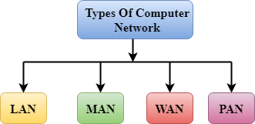

Local area network (LAN):
Local area network is a group of computers in a small area such as building, office, connected to each other. LAN is used to connect two or more personal computers via a media such as twisted pairs, coaxial cables, etc. it’s less costly because it is designed with cheap hardware such as hubs, network adapters and Ethernet cables. In the local network, the data is transmitted at an extremely rapid rate. Higher security are provided by the local area network.
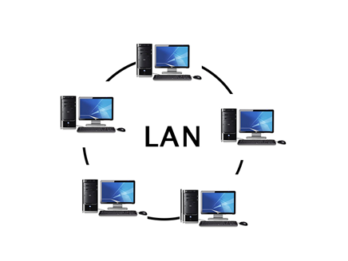

Metropolitan area network (MAN)
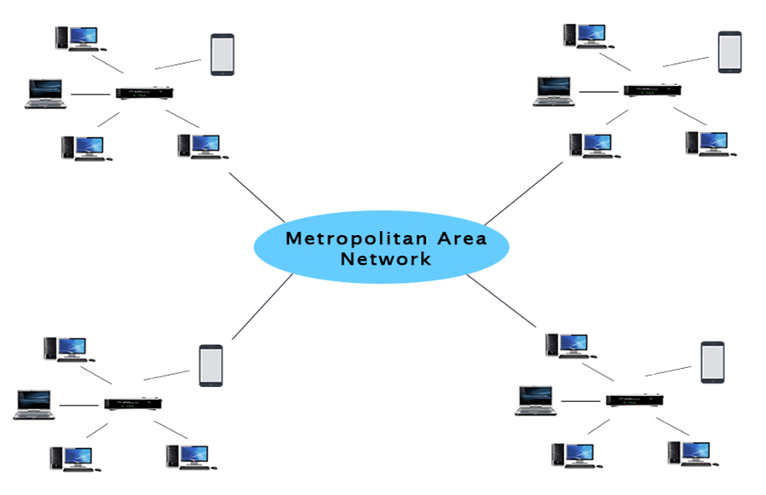
A network of metropolitan areas is a network that covers a larger geographic area by connecting a LAN to form a larger network. Government agencies use metropolitan area network to connect with the public and private sectors. Through metropolitan area network, a telephone exchange line connects various LANs to each other. RS-232, Frame relay, ATM, ISDN, OC-3 ADSL etc. are the most widely used protocols in metropolitan area network. It has a range higher than the local network (LAN).

Uses of MAN
- Metropolitan area network is used in a city’s banks correspondence.
- It can be used in a reservation for an airline.
- It can be used within a city at a college.
- It can also be used in military communication.
Wide area network (WAN)
A wide area network is a network that extends across a large geographic area such as countries or states. A wide area network is much larger than the LAN network. A wide area network is not limited to a single location but it extends through a telephone line, fiber optic cable or satellite connections over a wide geographical area. The internet is one of the world’s largest WAN. A wide area network is commonly used in the private business industry, government and education sectors.

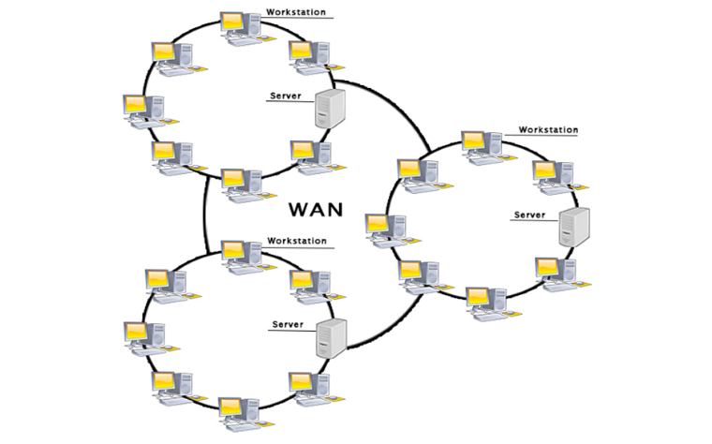

Examples of wide area network:
- Mobile broadband: A 4G network is widely used in a country or region.
- Last mile: A telecommunications company is used to provide customers in hundreds of cites with internet services by connecting their home with fiber.
- Private network: A banks connects the 44 offices with a private network.
Advantages of wide area network
The wide area networks advantages are as follows:
- Geographic area: a wide area network of areas provides a wide geographic area. Suppose if our offices branch is in another city then we can connect to them via WAN. The internet provides a leased line, which allows us to connect to another branch.
- Centralized data: data is centralized in the case of a WAN network.
- Get updated files: on the live server, software companies work. The programmers will therefore get the updated files in seconds.
- Exchange messages: messages are transmitted easily in a WAN network. You can communicate with friends via the web app like twitter, LinkedIn and Gmail.
- Software and resources sharing: we can share the software and other resources in the WAN network, such as a hard drive, RAM.
- Global business: over the internet, we can do business globally.
- High bandwidth: If we use our company’s leased lines, it gives us the high bandwidth. The high bandwidth increases the rate of the data transfer, which in turn increase our company’s productivity.
Disadvantages of wide area network
The following are the wide area networks disadvantages:
- Security issue: compared to the LAN and MAN network, a WAN network has more security issues as all technologies that create the security issue are combined.
- Needs firewall & antivirus software: the data is transmitted on the internet which the hackers can change or hack, so the firewall needs to be used. Some people can inject the virus into our system to protect from such a virus.
- High setup cost: the WAN networks installation cost is high because it involves purchasing routers, switches.
- Problems of troubleshooting: it covers a large area so it is difficult to fix the problem.
Personal area network (PAN)
Personal area network is a network that is arranged within an individual, typically within 10 meters. The personal area network is used to connect personal-use computer devices as the personal area network. Thomas Zimmerman was the first scientist to come up with the idea of the personal area network. A personal area network covers a 30-feet area. The laptop mobile phones, video players and play stations are personal computer devices that are used to develop the personal area network.
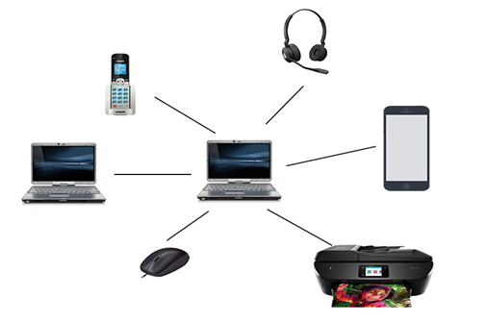

Two types of personal area network are usable:
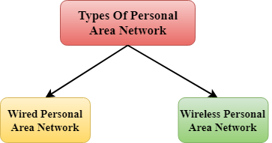

- Wired personal area network
Using the USB to create the wired personal area network.
- Wireless personal area network
Wireless personal network is developed by a simple use of wireless technologies like Wi-Fi, Bluetooth. It is a network with a low range.
Examples of personal area network:
- Body area network:
Body area network is a person network. A mobile network, for example moves with a person suppose a person establishes a network connection and then creates a connection for sharing the information with another device.
- Offline network:
It is possible to create an offline network inside the home, so it is also known as a home network is designed to integrate devices such as printers, computers, and television but there is no internet connection.
- Small home office:
Using a VPN, it connects a variety of devices to the internet and a corporate network.
Network infrastructure:
Network infrastructure is the hardware and software resources of an entire network that allows an enterprise network to connect, operate and manage. It provides users, process, applications services and external networks/the internet with the commutation path and services.
In most enterprise IT environments, network infrastructure is typically, part of the IT infrastructure. It interconnects the entire network infrastructure and can be used for internal communications, external communications or both. A typical infrastructure for the network includes:
Networking hardware:
- Routers
- Switches
- LAN cards
- Wireless routers
- Cables
Networking software:
- Network operations and management
- Operating systems
- Firewall
- Network security applications
Network services:
- T-1 line
- DSL
- Satellite
- Wireless protocols
- IP addressing
Network devices:
Network devices or networking hardware is physical devices required on a computer network to communicate and interact with hardware.
Types of network devices
Here is the list of popular devices on the network:
- Hub
Hubs connects multiple devices to computer networking. A hub also acts as a repeater by amplifying signals that deteriorate over connecting cables after travelling long distances. In the network connecting devices family, a hub is the simplest because it connects LAN components with the same protocols. A hub can be used for both digital and analog data as long as its settings are configured to prepare for incoming data formatting. For example, if the incoming data is in digital format, it must be transmitted as packets by the hub however if the incoming data is similar the hub must transmit it in signal from. Hubs do not search or address functions for packets; they simple transmit data packets to all connected devices. Hubs are operating on the open systems interconnection (OSI) models physical layer. Two types of hubs are usable: simple and multiple port.
- Switch
Generally, switches have a smarter role than hubs. A switch is a device that improves the efficiency of the network. The switch keeps limited node routing information in the internal network and allows connections to systems such as hubs or routers. Usually LAN strands are connected via switches. Typically speaking, switches can read incoming packets hardware addresses to be sent to the appropriate destination. Due to virtual circuit capability, the use of switches improves network efficiency over hubs or routers. Switches also improve network security because with network monitors the virtual circuits are harder to examine you will see a switch as a device that combines some of the best routers and hubs capabilities. A switch can either work in the OSI models data link or network layer. A multilayer switch is one that can operate on both layers which means both a switch and a router can operate. A multilayer switch is a high-performance device that supports the same protocols for routing as routers. Switches can be subject to distributed services denial (DDOS) attacks flood guards are used to prevent malicious traffic from stopping the switch. Switch port security is important to ensure that switches are secured: disable all unused ports and use DHCP snooping, ARP inspection and filtering of mac address.
- Router
Routers help transmit packets to their destinations by using different network topologies to chart a route through the sea of interconnected networking devices. Routers are intelligent devices and store information about the networks in which they are connected. Most routers can be configured to act as firewalls for packet filtering and to use ACLs. Routers are also used to translate from LAN framing to WAN framing in conjunction with a channel service unit/data service unit (CSU/DSU). This is necessary because LANs and WANs use different network protocols. Such routers are referred to as borders routers. They serve as a LANs external connection to a WAN and operate at the networks border. As well as diving internal networks into two or more subnetworks, routers are used. Routers can be also be connecting to other routers internally, creating independently operating zones. By maintaining tables about destinations and local connections, routers establish communication. A router contains information about the connected systems and where to send requests if you don’t know the destination. Routers usually using one of three standard protocols to communicate routing and other information: routing information protocol (RIP), border gateway protocol (BGP) and open shortest path first (OSPF). Routers are your first line of defence, and traffic authorized by network administrators must be configured to pass. It is possible to set up the routes themselves as static or dynamic. They can be configured manually if they are static and remain so until they are changed. If they are dynamic, they learn about routers around them and build their routing tables using information about those routers. Routers are devices that interconnect two or more heterogeneous networks for general purpose. Usually they are dedicated to special purpose computers, with separate network interfaces for each connected network input and output. As routers and gateways are the backbone of large computer networks such as the internet such as the internet, they have special features that give them the flexibility and ability to cope with different network-addressing schemes and frame sizes by segmenting large packets into smaller sizes that fit the new network components. Each routers interface is equipped with its own address resolution protocol (ARP) module, its own LAN address (network card address) and IP address. The router has knowledge of routes that a packet can take from its source to its destination with the help of a routing table. As in the bridge and switch, the routing table is growing dynamically. Upon receiving a packet, the router removes the packet headers and trailers and analyses the IP header by identifying the sources and destination addresses and type of data, and recording the time of arrival. It also updates the router table not already in the table with new addresses. The information about the IP header and time of arrival is entered in the routing table. Outers usually work on the OSI models network layer.
- Bridge
Bridge are used to connect two or more segments of hosts or networks. Bridges fundamental role in network architecture is to store and forward frames between the various segments connected by the bridge. To transfer frames, they use hardware media access control (MAC) addresses. Bridges can forward the data or block it from crossing by looking at the devices connected to each segment. You can also use bridges to connect two physical LANs to a larger logical LAN. Bridge only work on the OSI models physical and data link layers. By sitting between two physical network segments and managing the data flow between the two, bridges are used to divide larger networks into smaller sections. In many ways, bridges are like hubs, including connecting LAN components to the same protocols. However, before being forwarded, bridge filter incoming data packets, known as frames, for addresses. The bridge will not make any modifications to the format or content of incoming data as it filters the data packets. Use a dynamic bridge filters and forward frames on the network. Initially empty, the bridge table maintains the LAN addresses of each bridge interface connecting the LAN to other LANs. Bridge can be simple or multiple port like hubs. In recent years, bridge have mostly fallen out of favour and have been replaced by switches, which offer more functionality.
- Gateway
Gateways usually work on the OSI models transport and session layers. There are several protocols and specifications from various vendors at the transport layer and above, gateways are used to deal with them. Gateways provide communication between open system interconnection (OSI) and transmission control protocol/internet protocol (TCP/IP) networking technologies. Gateways therefore connect two or more autonomous networks, each with its own routing algorithms, protocols, topology, domain name service, and procedures and policies for network administration. Gateways execute all the routers and more functions. A router with added functionality of translation is essentially a gateway. A protocol converter is the function that translates between different network technologies.
- Modem
Modems are used to relay digital signals over analog telephone lines (modulators-demodulators). Therefore, the modem converts digital signals into analog signals of various frequencies and transmits them to a modem at the receiving site. The receiving modem carries out the revers transformation and provides a digital output to a modem- connected device, normally a computer. Normally, digital data is transmitted over a serial line to or from the modem via an industry standard interface, RS-323. Most telephone companies provide DSL services, and many cable operators use modems to classify and accept home and personal users as end terminals. Modems operate on both the layers of physical and data link.

- Repeater
An electronic device is a repeater that amplifies the signal it receives. For standard LAN cables, you can think of repeater as a device that receives a signal and retransmits it at a higher or higher power level to allow the signal to cover longer distances, more than 100 meters. Repeaters work on the layer of physics.
- Access point
While an access point (AP) may requires either a wired or a wireless link, a wireless interface is commonly referred to. An AP operate on the second layer of OSI, the data link layer and can act either as a bridge connecting a traditional wired network to wireless devices or as a router transmitting data from one access point to another. Wireless access points (WAPs) consist of a wireless LAN (WLAN) transmitter and receiver (transceiver) device. Separate network device with an integrated antenna, transmitter and adapter are typically access points. Aps use wireless network infrastructure mode to provide a connection point between WLANs and wired Ethernet LAN. They also have several ports, enabling you to extend the network to support more customers. Depending on the networking size, full coverage can require one or more Aps. Addition aps are used to allow more wireless clients to connect and extend the wireless networks coverage. Increasing AP is constrained by its range of transmission the distance a client can get from an AP and still get a usable speed of signal and data flow. The actual distance between the consumer and the AP depends on environmental conditions. Higher end Aps have high-powered antennas that enable them to extend the degree to which the wireless signal can travel. Aps may also provide several ports to increase the network capacity, firewall functionality, and dynamic host configuration protocol (DHCP) service. Then we get a switch, a DHCP server, a router and a firewall for aps. You need a name for the service set identifier (SSID) to connect to a wireless AP. 802.11 wireless networks use SSID to recognize all devices belonging to the same network and configure client stations with SSID to authenticate the AP. The AP may broadcast the SSID , allowing all wireless clients in the area to see the SSID of the Aps may be configured not to broadcast the SSID, which means that an administrator needs to provide the SSID to client systems rather than allowing it to be automatically discovered. Wireless apps carry SSIDs, for security settings, networks passwords and usernames by default. For security reasons, it is strongly recommended that you change these default settings as soon as possible as many websites list manufactures default settings.
  - Assess the function of components within a chosen computer system.
Components of computer system
- Computer hardware: are actual elements of a device/intangible pieces. E.g.: devices for input, output central processing and storage.
- Computer software: sometimes known as software or programs.
- Liver ware: is the use of the computer the human ware was also known as orgwareor. The user orders on instructions to run the computer system.
1.4 evaluate peripheral devices to meet different purposes
Input device:
You can enter information by a computer input device. Keystrokes on a keyboard and clicks with a mouse are the most basic pieces of information. In order to interact with your computer these two input devices are necessary. To enter other types of information, such as images, audio and video, there are many other input devices. Input devices the other two output devices and storage devices represent another type of computer peripheral.
Examples of input devices:
For any computer system, a keyboard is the most important input unit. It was usually the only input system in early computing days. A keyboard includes letter and number keys as well as complex functions like enter, delete etc.
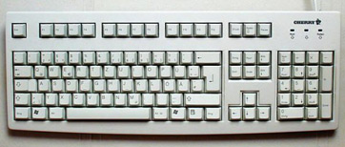

The mouse was created as a pointing tool when operating systems began using the graphical user interface (GUI). A cursor normally sits on a flat surface and you can move the pointer on the screen by rotating the mouse. You can enter instructions by clicking on one or more buttons on the keyboard. Some versions also have a scrolling screen.



Another common tool for input is an image scanner. A traditional desktop or flatbed scanner is a tool that scans and transforms printed photographs and paper documents into digital images for optical purposes. You put the paper on a glass plate in most scanners and put an opaque mask over it. A bright light moves through the image and a sensor captures the reflection that converts the document to
Output deceive
An output device is any device that is used to send data to another device or user from a computer. Many human sensitive computer data output is in the form of audio or video. Thus, in these categories ae the majority of output devices used by humans. Examples are monitors, projectors, speakers, headphones printers etc. output devices allow users and other devices to communicate with computers. This may include input/output peripherals such as network interface cards (NICs) modems IR ports RFID systems and wireless networking devices as well as mechanical output devices, such as solenoids, motors and other electromechanically devices. Some of the most common output devices people know about include monitors producing video output, speakers producing output and printers producing text or graphics output.

2.1 evaluate different operating systems explaining their role in managing resources
An operating system (OS) is the software that manages all the other application programs on a computer after being initially loaded into the computer by a boot program. Application systems use the operating system through the application program interface (API) to request services. However, users can directly interact with the operating system through a user interface such a command line or a graphical user interface (GUI).
For applications, an operating system may perform the following services:
- In a multitasking operating system, where multiple programs can run simultaneously, the OS determines which applications should run in which order and how much time should be allowed for each application before turning over to another application.
- It manages internal memory sharing between multiple applications.
- This manages input and output from and to connected hardware devices such as hard disks printers and ports for dial-up.
- It sends messages to each program or remote user (or to a device operator) about the state of service and errors that may have occurred.
- It can unload batch jobs management (e.g. Printing) in order to free the initiating program from this project.
- An operating system can manage how to partition the program so that it runs on more than one processor at a time on computer that can provide parallel processing.

2.2 critically assess the use of the different software applications to meet specific purposes
The term “software” refers to the set of instructions for the electronic program or data read by a computer processor to perform a task or operation. The term “hardware” on the other hand, refers to the physical components you can see and touch, such as the hard drive, mouse, and keyboard. Technology can be classified to do what it is intended to do.
There are usually two major software classifications, system software and application software.
- System software
A system software allows the user and the hardware to communicate with each other and connect. Essentially, it is a software to manage the Behavior of computer hardware to provide the user with basic functionality. Simply put, we can assume that system software is a middle layer between the user and the hardware. For the other software to work in, this computer software authorize a network or system. That is why system software is very important for the management of the entire computer system once you turn on the computer for the first time, it is the system software that is initialized and loaded into the system memory. In the meantime, the system software is running and is not used by end-users. That’s why system software is also referred to as “low-level software”.
Examples of common system software are:
Operating system: it is system software’s most prominent example. A software collection manages resources and provides general services for other applications running over them. While each operating system is different, most of them provide a graphical user interface that allows a user to access files and folders and perform certain tasks. Each computer, whether it is a desktop, laptop or cell phone, needs an operating system to provide it with the basic functionality. As an operating system ultimately defines how a user communicates with the system, so many users prefer to a use a different operating system for their computer. There are different types of operating system, such as real-time, embedded, distributed, multi-user, single-user, desktop, web etc. when selecting an operating system, it is important to consider the hardware requirements. Several examples of the following operating systems:
- Android
- Macos
- IOS
- Linux
- Ubuntu
- Unix
- Mac OS
- Windows
Device drivers
This is a kind of software that regulates different hardware connected to the device. Computer devices that allow a driver to connect to a system include displays, sound cards, printers, mice and hard disk drives. Two types of device drivers are also accessible: kernel device drives and user device driver. Serval system driver examples are:
- BIOS driver
- Motherboard drivers
- Sound card drivers
- USB drivers
- VGA drivers
- Virtual device drivers
- ROM drivers
- Printer drivers
Firmware
Firmware is the permanent program stored in a memory that is read-only. It is a compilation of permanently stored instructions on a hardware device. This provides important knowledge on how the computer communicates with other hardware. Firmware can be considered because “semi-permanent” as it remains permanent unless it is upgraded with a firmware updater. Few firmware examples are:
- BIOS
- UEFI
- Computer peripherals
- Embedded systems for consumer applications

Programming language translators
These are mediator programs on which software programs rly to simplify machine-level code by translating high-level languages content. The translator, in addition to simplifying the languages also do the following:
- Assign data storage
- Enlist source code as well as software information
- Provide diagnostic reports
- Correct system errors during runtime
- Interpreter, compiler and assembler are examples of programming language translators.

2.3 assess the use of web applications to enhance user experience.
Web application:
A web application or “web app” is a web server software program. Mobile apps must be accessed via a web browser, unlike traditional desktop applications powered through the operating system. Web apps have a range of benefits over desktop apps. Developers do not need to develop web apps for multiple platforms because they operate inside web browsers. For example, a single application running in chrome can operate on both windows and OS X. when the web app is modified, developers do not need to distribute software updates to users. All users have access to the updated version by updating the program on the server. A web app can have a more consistent user interface across multiple platforms from the user’s point of view, as the appearance depends on the browser rather than the operating system. The data you enter in a web app will also be processed and saved remotely. Instead of transferring files between computer systems, you can access the same data from multiple devices. Although web applications offer some advantages compared to desktop applications, they do have some disadvantages. Because they are not running directly from the operating system, there is limited access to system resources, such as the CPU, memory, and file system. High-end programs like video production and other media applications therefore generally perform better as desktop applications. Web applications also depend entirely on the web browser. For example, if your browser crashes, you could lose your unsaved progress. Web apps may also inconsistent with browser updates, causing unexpected problems. Some people prefer apps from the desktop, while others prefer web apps. As a result, many software companies now offer their most popular programs in both desktop and web versions. Microsoft office, apple iWork, and sense TurboTax are common examples. The files saved in the online version are mostly compatible with the desktop version and vice versa. For example, you can open and edit the file with the desktop version if you save a TAX2013 file in TurboTax online.
There are six types of the web applications.
- Static web application
- Dynamic web application
- Online store or e-commerce
- Portal web app
- Animated web application
Static web application
The first thing to know if you chose to create a static web app is that this type of web app shows very little functionality and is not very versatile. Typically, they are built in HTML and CSS. Animated objects like banners, GIFs, videos, etc. can also be included and displayed in them however, with jQuery and Ajax, they can also be created. Therefore, it is not easy to modify the content of static web apps. You must first download the HTML code to do this, then edit it and then upload it to the server again. Only the webmaster or the development company that first planned and designed the app can make these changes. Examples of development of static web apps include professional portfolios or digital curricula. Likewise, this type of web application could also be used by a web page advertising a business to view contact information or similar.
Dynamic web application
Dynamic web applications at a technical level are much more complex. They use databases to load data and update their contents whenever the user accesses them. We typically have an administration panel (called CMS) that allows administrators to correct or change the content of the app, including text and images. For the development of dynamic web applications, several different programming languages can be used. PHP and ASP are the most frequently used languages because they allow you to organize the content. Upgrading content in this form of app is very easy and you do not even have to access the server when you alter it. This also includes other features such as forums or databases to be implemented in addition to content design can be modified to match the preference of the administrator.
Online or e-commerce
If the web application is an online store or shop, it is likely that its development will resemble that of m-commerce or e-commerce. The development process of this type of app is more complicated as it must enable electronic payments via credit cards, PayPal or other methods of payment. The development must also create the administrators management panel. It will be used to list, update or uninstall new products and manage orders and payments. The el Corte ingles department store is an example of a major Spanish company that has developed a web application for an online store. The web app suits mobile devices in the same way that a mobile app does, allowing it to connect as if it were a native app.
Portal web app
By portal, we refer to a type application in which, through a home page, we access serval of its sections or categories. Such programs can include several things: forums, conversations, emails apps areas accessible through registration, the latest content, etc.
Animated web app
Flash technology is necessarily synonymous with an animation. This programming approach enables animated impact material to be viewed. It also makes for more imaginative and futuristic projects and is one of designers and creative directors most commonly used innovations. The internet drawback to developing animated web applications is that this type of technology is not appropriate for web positioning and SEO optimization purpose because search engines are unable to read the information found there in correctly.

2.4 assess the use of mobile applications to enhance user experience
Mobile applications:
Most commonly referred to as an app, a mobile application is a type of application software designed to run on a mobile device, such as a smartphone or tablet computer. Mobile applications also serve to provide similar service for users to those accessed on PCs. Apps are generally small individual units of apps with limited functionality. Apple Inc. and is app store first popularized this use of app software, which provides thousands of apps for the iPhone, iPad and iPod touch. An email, web app, internet app, iPhone app or smart phone app may also be recognized as mobile app. Mobile applications are a move away from built-in software systems commonly found on PCs. Alternatively, each app offers restricted and isolated functionality such as a game, calculator, r mobile web browser. While applications may have avoided multitasking due to the limited hardware resources of the early mobile devices, their specificity is now part of their desirability, as they allow consumers to choose what their devices can do. The easiest mobile apps take applications running on PCs and then move them to a mobile device. This approach is somewhat lacking as the mobile apps become more robust. A more sophisticated approach involves specifically developing for the mobile environment, taking advantage of both its limitations and its advantage.
For example, apps that use location-based functionality are typically designed with eyes to mobile from the ground up, since the consumer does not have the same location concept on a PC.
There are four types of the mobile applications
- Native apps
- Mobile web apps
- Progressive web apps
- Hybrid web apps
Native apps:
Native mobile devices are specifically designed for a specific type of operating system. They are called native because they are native to a particular device or platform. Apps built on one type operating system. Android apps, in other words, cannot be used on an iPhone. They use the development tools and language by the respective platform (e.g., iOS X-code and objective-C, Eclipse, and android java). This provides full access to controls of all apps, such as contacts, camera, sensors etc. native applications can be downloaded through e.g. - android apps on google play stores, iOS apps on the app store, etc.
Example of the native apps:

Using native device operating system APIs and SDKs, mobile native apps ae created. These are programmed using platform-specific languages such as the iOS objective C, android java, and windows phone. One can use the standard GUI components that are part of the SDK stack, quickly creating a native and straightforward. Such applications will be able to access all computer hardware including the different sensors and peripherals if any. These apps are fast since the executable is compiled for the particular OS and directly on the OS. They come with their development environments to do actual system testing, including different simulators and infrastructure.
Mobile web apps:
These are the desktop frameworks or delivering web pages on mobile devices running web browsers. These are cloud-based mobile apps that are not installed on your mobile handheld device and run on servers hosted on the internet. Mobile web applications usually use web technologies such as HTML, CSS, JavaScript and JQuery. We cannot control all of the functionality of native devices (camera, calendar, geolocation, etc.).
Examples of mobile web apps:
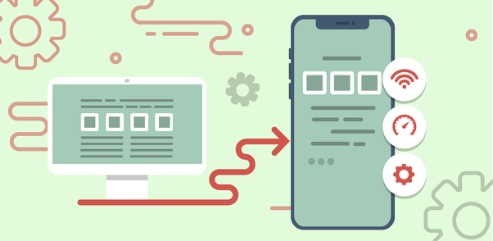
The architecture of mobile web apps:
Mobile web apps are designed to run on your mobile web browser. These are built using multiplatform web technologies such as HTML5, CSS and JavaScript. Thus, it is safe to consider HTML5 as the technology of choice for developing mobile web apps.
Hybrid apps:
Mixtures of desktop and mobile web applications are hybrid apps. They live in an app store like native apps, and can take advantage of the many device that are available. Unlike web apps, they rely on HTML being made in a browser, with the exception of embedding in the app. These are built using frameworks such as HTML, CSS, JavaScript, JQuery, mobile, Cordova/ phone gap etc. hybrid applications, including native apps, are also installed in the system, and disturbed through the app store. These are ideal for developing apps that do not have a high-performance requirement but require full access to the device.

Examples of hybrid apps:


Progressive web apps:
Progressive web apps are like regular web sites but provide additional user functionality such as offline service, and access to computer hardware that was previously only available to mobile apps from local websites. The great thing about PWAs is that they can be accessed on the smartphone home screen via an app icon and leads to the apps website as soon as you click. PWAs are state of

REFERCENCE
- https://www.computerhope.com/jargon/m/memory.htm
- https://www.computertechreviews.com/definition/ram-random-access-memory
- https://www.slideshare.net/geeksagar/primary-memory-ram-rom-and-their-types?qid=c6406a29-bc02-4da8-84bd-fdc61ef58616&v=&b=&from_search=1
- https://www.techopedia.com/definition/25597/computer-network
- https://www.javatpoint.com/types-of-computer-network
- https://www.techopedia.com/definition/16955/network-infrastructure
- https://blog.netwrix.com/2019/01/08/network-devices-explained/
- https://study.com/academy/lesson/what-is-an-input-device-for-a-computer-definition-examples-quiz.html
- https://peda.net/kenya/ass/subjects2/computer-studies/form-1/the-computer-system
- https://whatis.techtarget.com/definition/operating-system-OS
- https://squareboat.com/blog/different-types-of-software-with-examples
- https://techterms.com/definition/web_application
- https://en.yeeply.com/blog/6-different-kinds-web-app-development/
- https://www.techopedia.com/definition/2953/mobile-application-mobile-app

